THAILAND PRIVILEGE CARD CO., LTD.
AIRPORT SERVICES DIVISION
Member Meeting Point Guidelines
Elite Personal Assistant (EPA) Service — Departure & Arrival Procedures
1. DEPARTURE — MEMBER MEETING POINTS
Version 1 — Member Booked Limousine Service
The assigned driver shall bring the member to Level 4 (Departure), meeting at the outer entrance door nearest to the check-in counter of the member's airline for that day.
Version 2 — Member Travels to the Airport Independently (No Limousine Booked)
• If the member can be reached: meet at the location agreed with the member.
• If the member cannot be reached: the default meeting point is Level 4 (Departure), at the check-in counter of the member's airline for that day.
Fast Track — Departure
Location | Description
Point 1 | Level 4 (Departure), near Row A
Point 2 | Level 4 (Departure), near Row T
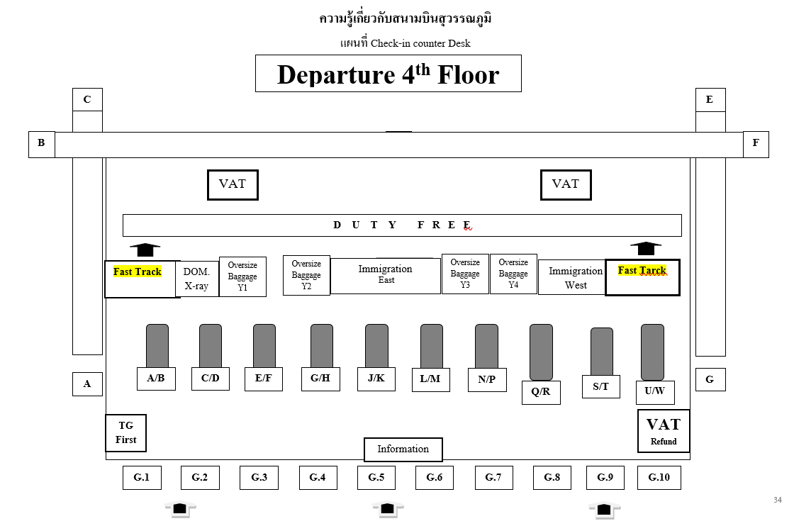
2. ARRIVAL / Connecting — MEMBER MEETING POINTS
• Jet-bridge gates (aircraft connected directly to the terminal): meet the member at the arrival gate, Level 2.
• Remote bay gates (aircraft not connected to a jet bridge): meet the member at the escalator opposite the Transit Concourse D area, Level 2.
Fast Track — Arrival
Member Type | Fast Track Entry Point
Visa members (TPC) | Premium Lane, Central Zone, Level 2 (Arrival)
Non-visa members (TPP) | Priority Lane, East and West Zones, Level 2 (Arrival)


